**Cascading Style Sheets**

1. CSS(Cascading Style Sheets )
2. Styles define how to display HTML elements
3. The W3C maintains a CSS3 progress report
4. Styles are normally saved in external .css files.
5. External style sheets enable you to change the appearance and layout of all the pages in a Website, just by editing one single file!
6. A Style Rule is composed of two parts: a selector and a declaration.
   1. The Selector indicates the element to which the rule is applied.
   2. The Declaration determines the property values of a selector.
      1. The Property specifies a characteristic, such as color, font-family, position, and is followed by a colon (:).
      2. The Value expresses specification of a property, such as red for color, arial for font family, 12 pt for font-size, and is followed by a semicolon (;).
   3. Selector{property: value} Eg: **p {color: red; }**
   4. Comments
      1. /*This is a comment*/
7. The id and class Selectors
   1. In addition to setting a style for a HTML element, CSS allows you to specify your own selectors called "id" and "class".
   2. The style rule below will be applied to the element with id="para1":
      1. **#para1{text-align:center;color:red};**
   3. all HTML elements with class="center" will be center-aligned:
      1. .center{text-align:center;}
8. Three Ways to Insert CSS
   1. External style sheet
      1. <head> <link rel="stylesheet" type="text/css" href="mystyle.css" /> </head>
   2. Internal style sheet
      1. 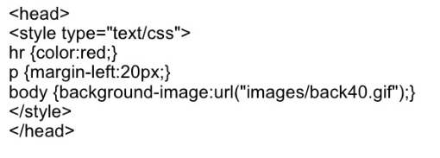
   3. Inline style
      1. <p style="color:red;margin-left:20px">This is a paragraph.</p>
   4. If some properties have been set for the same selector in different style sheets, the values will be inherited from the more specific style sheet.
   5. Font Family
      1. The font-family property should hold several font names as a "fallback" system. If the browser does not support the first font, it tries the next font.
      2. p{font-family:"Times New Roman", Times, serif;}
9. Styling Links
   1. Links can be style with any CSS property (e.g. color, font-family, background-color).
   2. Special for links are that they can be styled differently depending on what state they are in. The four links states are:
      1. a:link - a normal, unvisited link
      2. a:visited - a link the user has visited
      3. a:hover - a link when the user mouses over it
      4. a:active - a link the moment it is clicked
10. List styles
    1. ul.a {list-style-type: circle;}
    2. Ul.b {list-style-type: square;}
11. Box model
    1. 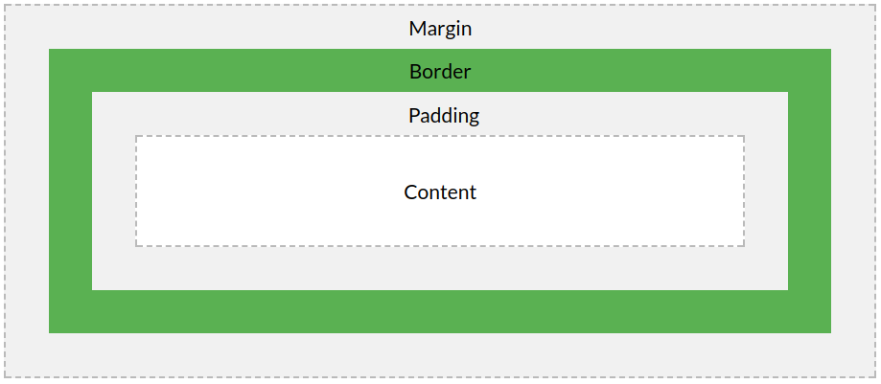
    2. Content - The content of the box, where text and images appear
    3. Padding - Clears an area around the content. The padding is transparent
    4. Border - A border that goes around the padding and content
    5. Margin - Clears an area outside the border. The margin is transparent
12. Advantages:
    1. CSS saves time
    2. Pages load faster
    3. Easy maintenance
    4. Superior styles to HTML

**Assignment**:

1. Convert image in css_assignmen1.jpg to HTML
   1. Notes:
      1. Logo should be img tag inside an anchor tag
      2. Use ul li for menu
      3. Use two divs for left and right block
      4. Do single listing and the rest should be copy pasted
      5. Open in GIMP so that you can pick the colors
      6. Right side block should list anchor tags under ul li.
      7. Box should center align
      8. Use Arial for font
      9. Do not use table
2. Convert image in css_assignmen2.jpg to HTML .